

Southern California Edison
CS Re-Platform Project

CIM-CS-08 Complaints, Claims and Survey
Customer Interaction Management
Business Process Design
Version 1.2

Table of Contents
1 Business Process Overview 4
1.1 Current Pain Points for Southern California Edison 4
1.2 Responsible Parties 4
1.3 Document Control 5
1.4 Terminology 5
2 Business Process Design 7
2.1 Types of Complaints 11
2.1.1 Consumer Affairs Complaint 11
2.1.1.1 CPUC Complaint 13
2.1.1.2 Local Public Affairs 14
2.1.1.3 Executive Complaint 14
2.1.1.4 Social Media Inquiries 14
2.1.1.5 CCA/DA 14
2.1.2 General Front Office Complaint 15
2.1.2.1 SCE.COM or Mobile App is down 15
2.1.2.2 Force onto eBill 15
2.1.2.3 Program Related Complaint 15
2.1.2.4 Correspondence Inquiries / Complaints 15
2.1.2.5 Field Personnel and Employee 15
2.1.2.6 Trade Professional 15
2.1.3 CS Information Governance 16
2.1.3.1 Solar/ 3rd Party 17
2.1.3.2 Bill Scam/Fraud 17
2.1.3.3 Privacy 18
2.2 Process / Performance Improvement 19
2.3 Prerequisites and Inputs 19
2.4 General Assumptions 19
2.5 Business Process Hierarchy 19
2.6 Process Flows 20
2.6.1 Create Complaint 20
2.6.2 Manage Complaint 24
2.7 3rd Party and SCE Legacy System Integrations 26
2.8 Data Elements 26
2.8.1 Create Complaint BPEM case 26
2.8.2 Edit Complaint BPEM case 27
2.8.3 Create Activity 28
2.8.1 Create Ticket 29
2.9 Cloud for Customer (Hybris C4C) Integration 30
2.9.1 Processes 30
2.9.2 Activity Records 30
2.9.3 Service Order 30
2.10 Exception Management Requirements 31
2.11 Process Risks and Mitigation 31
2.12 Key Performance Indicators 31
2.12.1 Key Metric Definition 32
3 Controls, Regulatory Rules, and Security 33
3.1 Security Considerations 36
3.2 Custom Program/Transaction Codes 36
3.3 Custom Table/Transaction Codes 37
3.4 Data Criticality and Cybersecurity Baseline Risks 37
4 Technical Considerations 39
4.1 RICEF-W Assessment 39
4.1.1 Reports 39
4.1.2 Interfaces 40
4.1.3 Conversion 40
4.1.4 Extension/Enhancements 40
4.1.5 Forms 41
4.1.6 Workflows 41
4.2 IDEX Considerations 41
4.3 Production System Cut-over Considerations 41
4.4 Other Considerations 41
5 Change Management 42
5.1 Change Impacts 42
6 Requirements 46
7. Appendix 47

This page intentionally left blank

Business Process Overview
SCE has a comprehensive process in handling various types of Complaints from customers.
If the complaint is resolved by the user during the call with the BP, an Activity will be created by the user manually in Hybris C4C documenting the call and no further action is required from the user. However, if the complaint is not resolved by the user, a Ticket will be created by the user manually in Hybris C4C and the Ticket will be routed to a lead or the appropriate person for action. If the person is unable to resolve the issue, they will route the Ticket to a supervisor or manager. If escalation is needed to Consumer Affairs, a BPEM will be created from the Ticket or C4C FOP. BPEM created via C4C FOP enable creation of BPEM at any object as ticket only allows BPEM creation at BP Object. The BPEM created will be available in BDEX for Consumer Affairs or CS Info Governance to work on. Each person who worked on the issue will be responsible for manually creating an Activity or update the long text in the BPEM to document the action they have taken.
All utility specific functions of the S/4HANA landscape, in concert with the Hybris C4C components are collectively referred to in this document as the SAP Customer Relationship and Billing solution, or simply CRB.

Current Pain Points for Southern California Edison
- Multiple systems are being used to conduct customer survey
- Many systems are being used to capture complaints, compliments and survey response
- Consumer Affairs Department does not have insight into complaints through all channels, limiting the ability to receive the escalation through the CPUC or to obtain the survey response from a customer resulting in duplicate complaints and unnecessary legwork. Additionally, this requires a lot of time manually researching issues in the system to pull together the history of the escalation.
- No 360 degree view of the issue reported by the customer
- No visibility of the escalation of a customer’s issue across all business units as they occur, resulting in complaints to the regulators
- Outdated complaint code types / sub-types that don’t align with our core business today and are complicating to update requiring IT involvement
- Trend analysis is currently a highly manual process to get to the root cause of a customer’s experience

Responsible Parties
Contact | Contact Person
Southern California Edison Business Process Owner | Janet Covington
Southern California Edison Lead | Christine Evans
HCL Functional Lead | Adrian Halim
Solution Architect | Pedro Costa
Front Office Lead | Christine Evans
Subject Matter Experts | Jonathan Ellis, Jerry Aguilar, Deborah Tillman, Scott Hirth, Natalie Martinez
Key User Group | CCC, BCD, Consumer Affairs, CP&S-Info Gov

Document Control
Version | Description of Change | Date | Author
0.1 | Creation of Initial Version | 02/01/2018 | Tuan Howe Yap
0.2 | Review by HCL CIM Lead | 02/19/2018 | Adrianus Halim
0.3 | Update based on review | 02/27/2018 | Tuan Howe Yap
0.4 | Update based on Security, Exception and Control review | 03/05/2018 | Tuan Howe Yap
0.5 | Update based on Pedro review | 03/07/2018 | Tuan Howe Yap
0.6 | Update based on CSRP review | 03/16/2018 | Tuan Howe Yap
0.7 | Update based on business review | 03/23/2018 | Tuan Howe Yap
0.8 | Update CSIG complaints | 04/22/2018 | Tuan Howe Yap
0.9 | Updated CyberSecurity section for Prakash | 04/26/2018 | Tuan Howe Yap
1.2 | Update based on SCC 262 and new business process | 06/19/2019 | Tuan Howe Yap

Terminology
Term/Acronym | Definition and SAP Equivalent (if applicable)
APSE | Accelerated (or Axon) Project Support Environment
BBP | Budget Billing Plan, equivalent to Level Pay Plans in SCE CSS
BDEX | SAP add-on functionality to support the processing of BPEM Cases
Billing Cycle | Is a group of contracts to be billed together via date-driven or regional criteria, it controls the billing cycle and is linked to the Meter Reading Unit. SAP equivalent term is the Portion.
Billing Document | A document that outlines the charges incurred for energy consumption for a specific contract. During the process of Billing, a billing document is generated for each contract on a contract account.
BMD | Business Master Data. The customer information which includes personal details, payment terms, dunning levels, billing rates and rate categories. The business master data objects are Business Partner, Business Agreement/Contract Account and Contract.
BP | Business Partner
BPD | Business Process Design (or Document)
BPEM | Business Process Exception Management
BWR | Basic Work Request. SAP equivalent is BPEM.
CA | Contract Account
CCRP | Customer Champion Recognition Program
Channel | Data object in SAP that holds the interval data. Intervals can be kwh, price, factor, etc. SAP equivalent is Profile.
CIMS | Customer Information Management System in SharePoint
Clarification | A list of payments that could not be processed and require additional work in order to be posted.
Connection Object | Link between installation and postal regional structure. Usually a building, but can also be a piece of property or other facility, such as a fountain or construction site. The connection object corresponds to the functional location in plant maintenance (PM).
Customer | Any entity with a relationship with SCE. This term is usually used in reference to customers (both individuals and organizations) This can include employees and third party suppliers (banks and payment partners). SAP Equivalent is Business Partner (BP)
CRB | SAP Customer Relationship & Billing system. This is what is being implemented with the CSRP program.
CSR | Customer Service Representative
EAM | SAP Enterprise Asset Management
S/4HANA | SAP ERP Central Component (SAP) - The core SAP modules (FICO, WM, SD, EAM, HR). This term is commonly used to refer to the existing SAP modules implemented at SCE.
ERP | SAP Enterprise Resource Planning
IMG | SAP Implementation Guide - where configuration is performed
Level Pay Plans | SAP equivalent term is Budget Billing. Budget Billing allows customers to pay regular equal amounts over a yearly period.
PoD | Point of Delivery, an object in Installation
SCE | Southern California Edison
Summary Billing | Standard SAP functionality that enables the invoicing of multiple Contract Accounts under one Parent Contract Account (Consolidated Summary Billing). SAP equivalent is Collective Billing.
TMD | SAP Technical Master Data E.g. Connection Object, Premise and Device Location

Additional terms may be found in APSE General Document # 32 CSRP Glossary

Business Process Design
This section of the document contains the business process for handling Complaints.
There are 3 methods to log and track complaints in Hybris C4C and they are:
- Ticket: Is used by Front Office users such as CCC/BCD to assign work to other employees or departments or to escalate a call/complaint to another individual or group i.e. supervisor. Refer to BPD to BPD CIM-CS-06 - Handle Customer Inquiries for more information on Ticket.
- BPEM Case: Is used when the Front Office supervisor/manager is not able to resolve the complaint and requires the user to refer the complaint to Consumer Affairs or CS Info Governance. The BPEM Case is created from a Ticket or C4C FOP. BPEM Case created from a Ticket can reference to BP Object. BPEM Case created from C4C FOP can reference to any SAP Object configured for the BPEM Case. Refer to BPD EM-01 - Exception Work Assignments for more information on BPEM Case.
- Service Orders will be created in C4C when field personnel are required to go to the site to resolve the issue such as debris left by field personnel.
An Activity will be created manually by each individual who attempted to resolve the escalated call/compliant.

Ticket
When CCC/BCD/other front office user is not able to resolve an issue/request, the user will log a Ticket using a Hybris C4C. User will locate the BP to create a Ticket (Figure 1: Ticket). User will select the Subject, Priority, Category, Sub-Category and long text in the ticket.

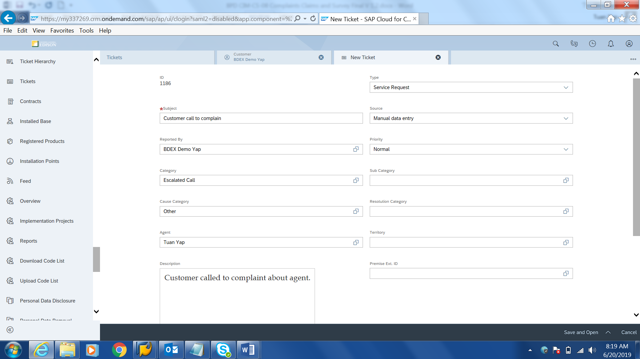
Figure 1: Create Ticket

The user will monitor the Tickets assigned to them via Ticket Monitoring Report in Hybris C4C (Figure 2: Ticket Monitoring Report). User is able to filter the search list based on various attributes such as Ticket Number, Status, Priority, etc. Refer to BPD CIM-CS-06 - Handle Customer Inquiries for more information.
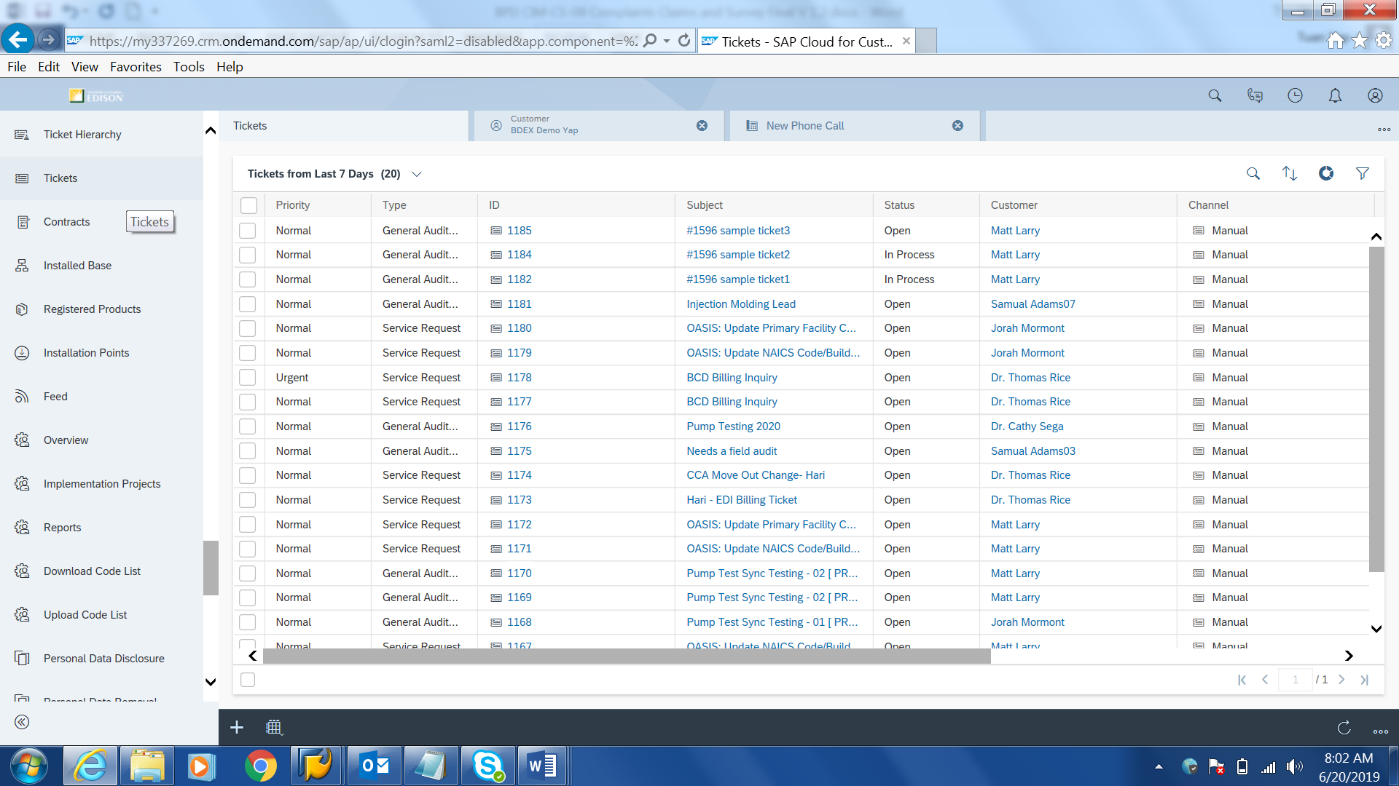
Figure 2: Ticket monitoring report

If the user is able to resolve the request/issue logged in a Ticket, the user will update the Ticket status to completed and provide the resolution (Figure 3: Update Ticket). If the user is not able to resolve the request/issue, the user will document the action taken and escalate the Ticket to the next level person (supervisor or manager). If the Ticket needs further escalation, the use will close the Ticket and create a BPEM within the Ticket or via C4C FOP. BPEM case created will be worked by Consumer Affairs, CS Info Governance or other organization (e.g., RSO Billing; BCD Customer Choice Solutions).

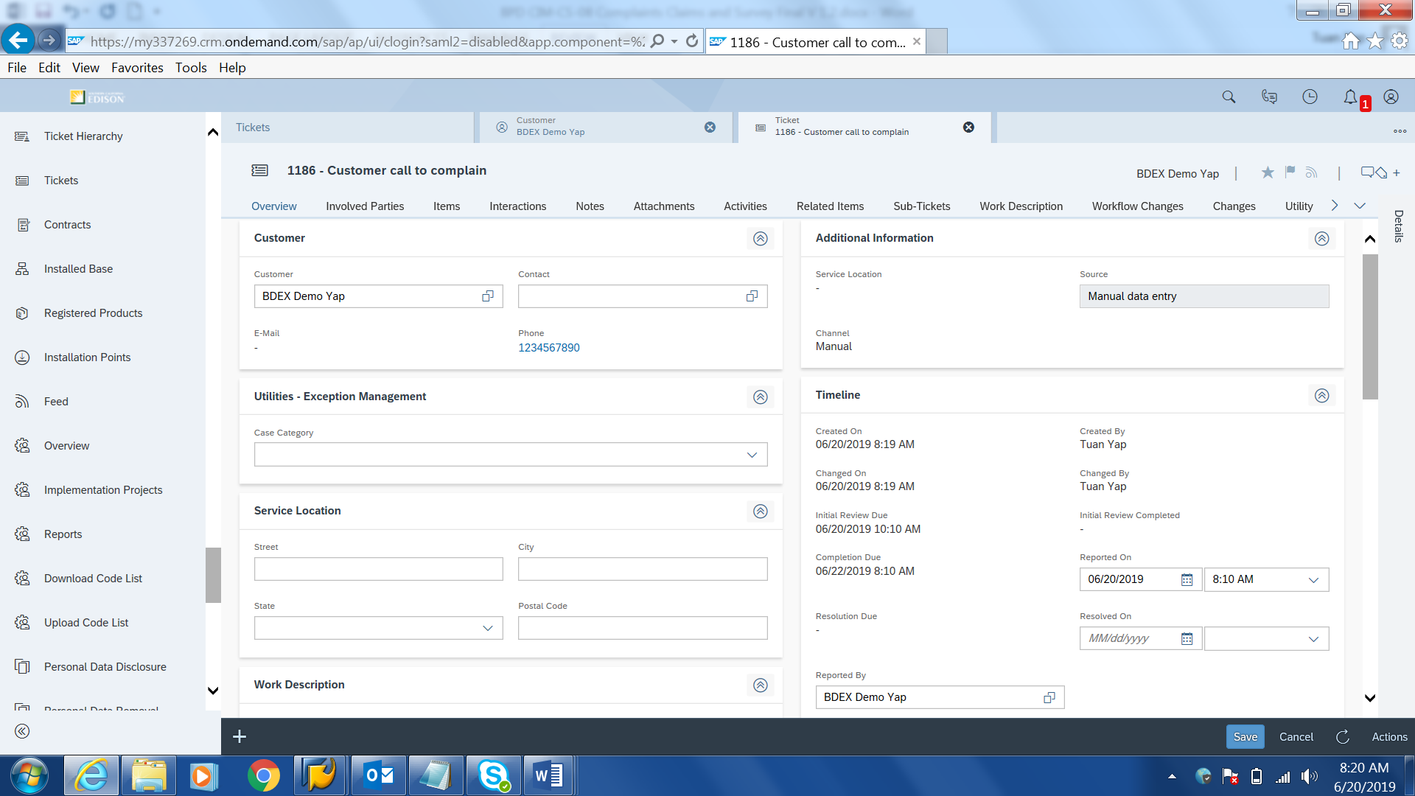
Figure 3: Update Ticket

BPEM Case
When creating a complaint BPEM case in Hybris C4C via Ticket, the user will select a specific complaint type (BPEM Case Category), enter the complaint information and save the record. BPEM cases will have a due date auto defaulted and this will be done via configuration. Long text from the Ticket will be copied to BPEM Case long text automatically. User can document additional information related to the complaint in the BPEM case in the field Long Text.
Priority for each of the BPEM case (complaint category) is defaulted by the system and priority is not shown in Hybris C4C view. User is able to update the priority in the S/4HANA through the change BPEM case transaction (EMMAC2) in the right-click action menu within the BDEx exception management tool.
If SCE decides to retire a complaint type in the future, this complaint type will not be available for users to select in the BPEM case creation functionality in Hybris C4C. This can be done by deactivating the BPEM Case Category in S/4HANA using Tcode EMMACCAT3and will be done by SCE IT. Historical BPEM cases that retired will still be visible to the user in Hybris C4C and S/4HANA and for reporting purposes. Governance will be established by SCE to review and approve removals and addition requests
Complaint related documents can be uploaded to any SAP object such as BP, Contract Account, Contract or Premise. Refer to BPD document CIM-CS-09 - Manage Inbound Request for more information.

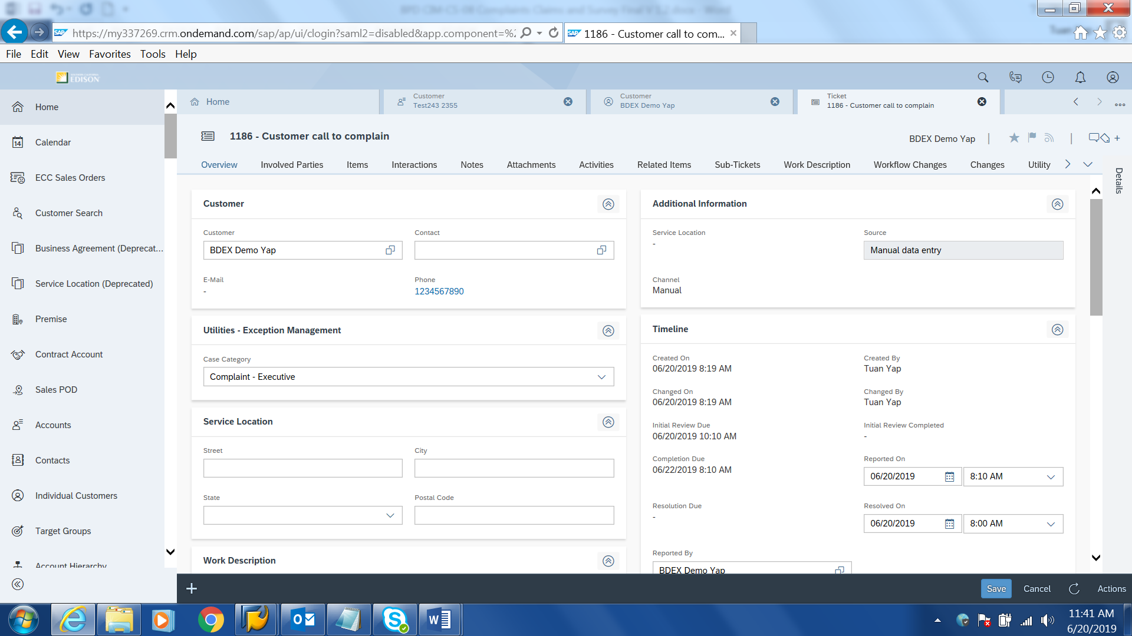
Figure 4: Create BPEM

BPEM Case that created via Ticket will contain Ticket ID when user view the BPEM Case via S/4.
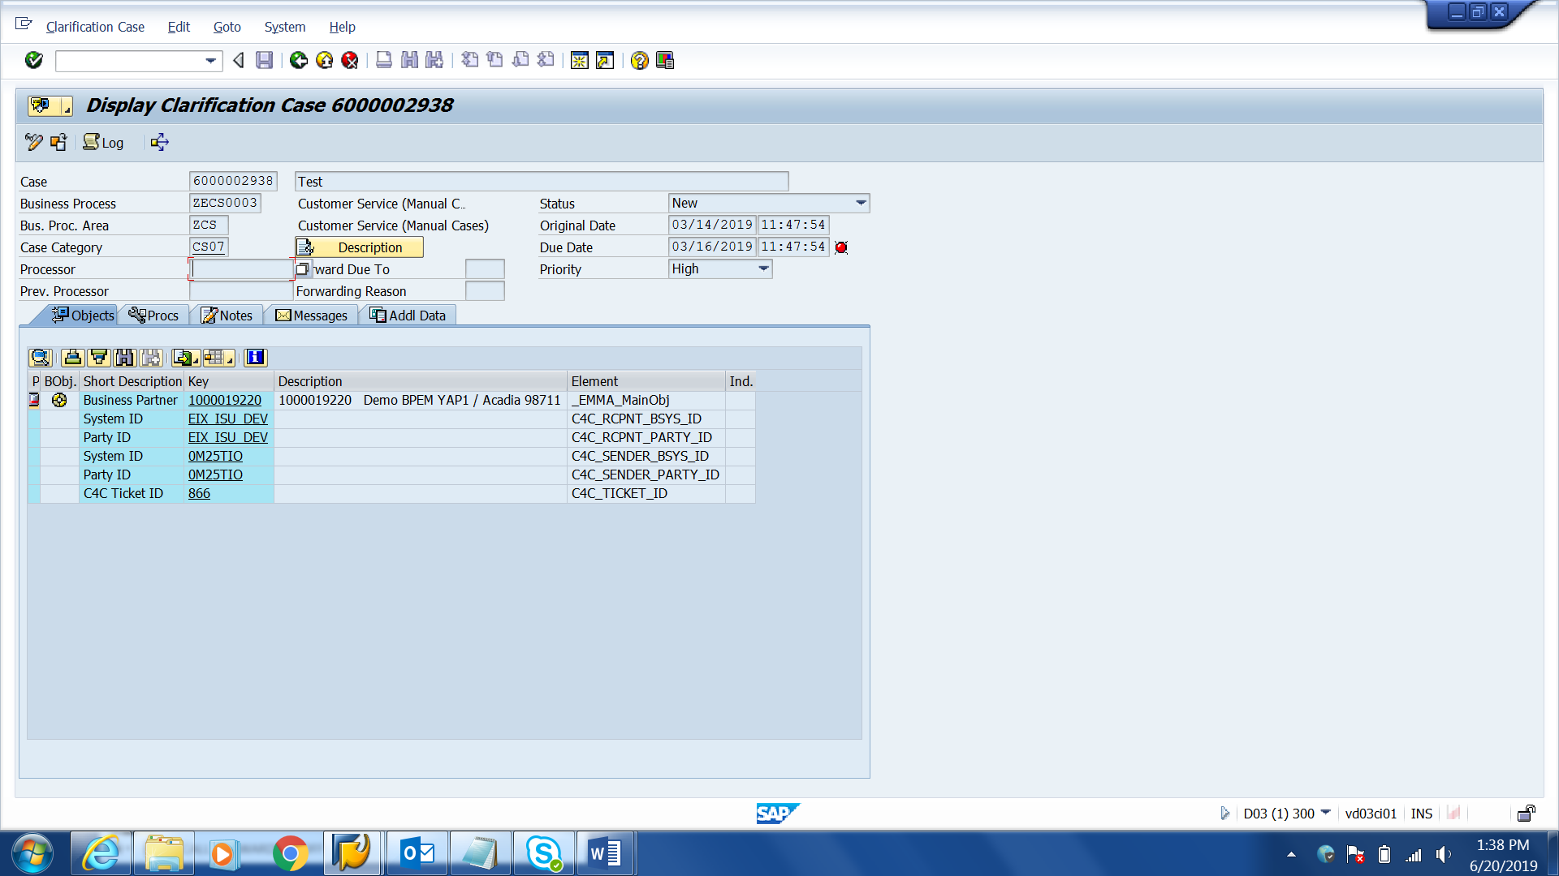

BPEM Case created via Ticket or S/4 can be viewed in C4C. If the BPEM Case was created via Ticket, the Service Ticket ID will be visible in the Service Ticket ID column.
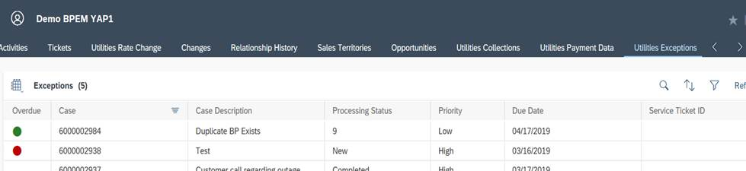

Service Order
A Service Order can be created via Hybris C4C (Figure 5: Create Service Order).
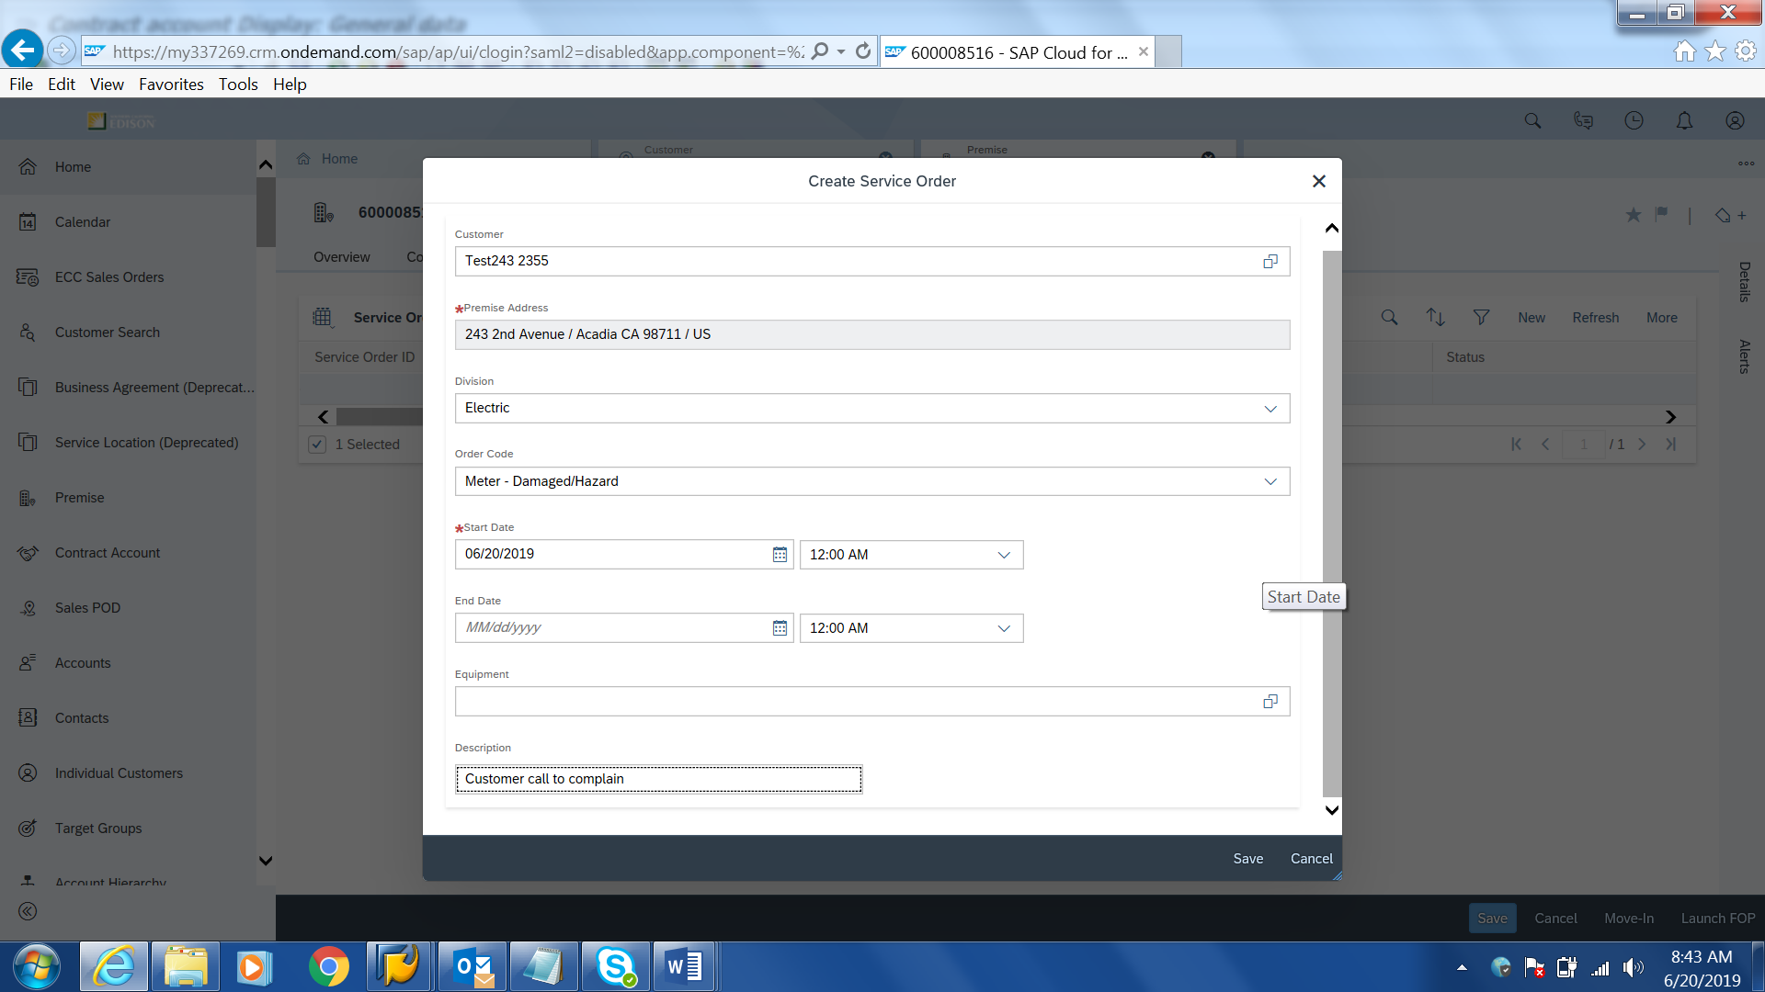
Figure 5: Create Service Order

User is also able to search for a specific or a list of Service Orders via S/4HANA Tcode IW38 (Figure 6: Service Order Listing). Refer to BPD DF-WM-02 - Handle Field Orders - Manage Field Orders for more information about IW38.

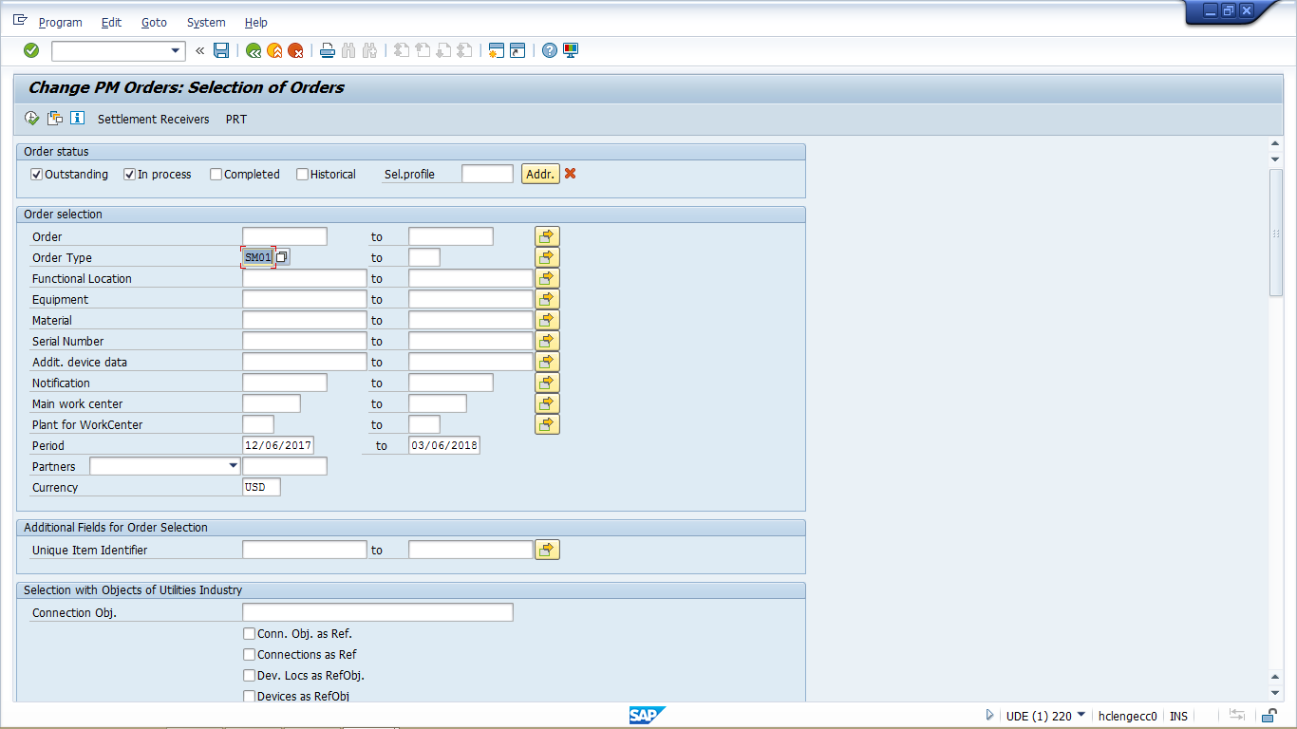
Figure 6: Service Order listing

Types of Complaints
Complaints can originate from the sources below.
- Ticket/BPEM created from Front Office users
- Email
- US Mail
- Social Media
- CPUC Consumer Affairs branch (Customer Information Management System – CIMS)
- Local Public Affairs (LPA)/BCD Account Manager (AM)/BCD Account Coordinators)
- Ethics and Compliance
- Phone calls
- IVR
- In Person visit
- Other correspondence
- Fax

Consumer Affairs Complaint
BPEM cases assigned to Consumer Affairs can only be viewable by Consumer Affairs or user with authorization.

Central view of BPEM cases

A central view for all BPEM cases created for complaints is available in S/4HANA via BDEx Dynamic Work Center (Tcode /BTI/BWC) by authorized users. Authorized user will be able to retrieve the Complaint BPEM case by clicking on the Get Work button within the DWC and see the list of BPEM cases that are assigned to him/her (Figure 7: BDEx Dynamic Work Center. Refer to EM-01 – Exception Work Assignments for work assignment detail). Authorized user is able to double click on the line item to see detail of BPEM case. User can call the BDEx Customer Centric Hub from the right-click menu of the BPEM case and proceed with the exception resolution process (refer to BPD EM-02 – Exception Work Views for more information). Complaint BPEM case will be controlled using BPEM case authorization object ‘CRT/UPD/DIS, B-EMMA-CAS’ Activity and Authorization group configuration.

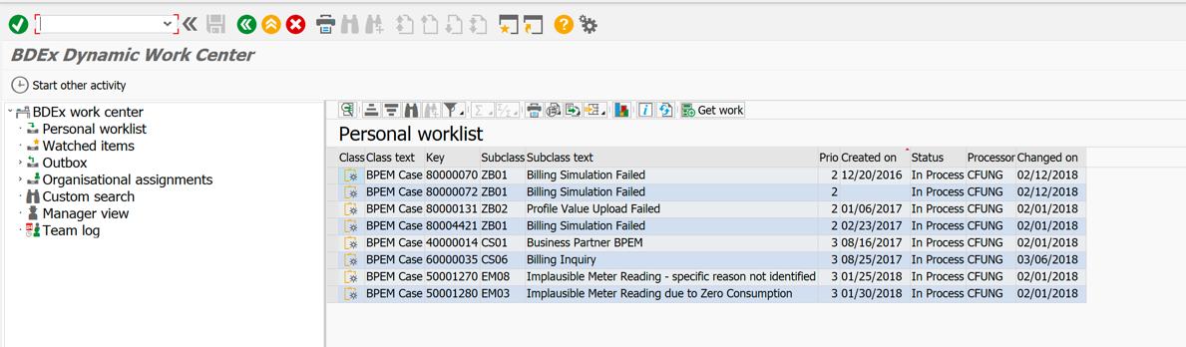
Figure 7: BDEx Dynamic Work Center

A standard BDEx report (BDEx BPEM Summary Report ) is available in S/4HANA (Figure 8: BPEx BPEM Summary Report). This report can be executed by transaction /BTR/PP_ASTROLABE and /BTR/PP_SUM to display the report for users to get a count of the number of complaint BPEM cases that are created for a specific date, still outstanding and closed. Refer to BPD EM-03 - Exception Management Analytics for more information.
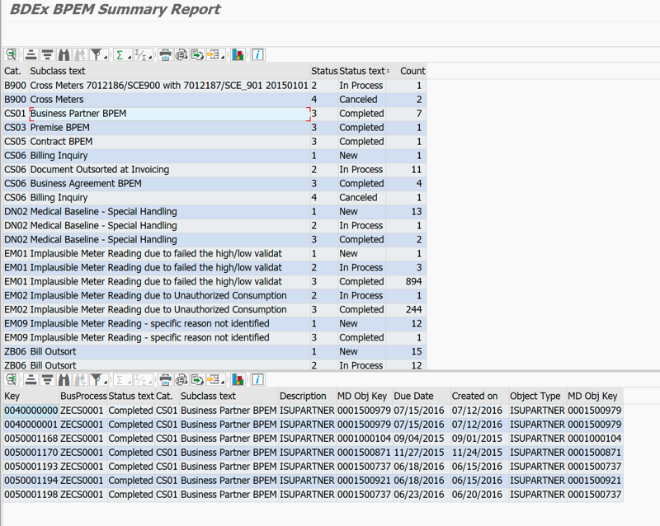
Figure 8: BDEx BPEM Summary Report

Users can also utilize S/4HANA BDEx BPEM Summary Report to extract the following information:
- Provide the number of BPEM cases for complaints that are being created. When a user double clicks on result list, the report will have information such as BPEM case number, created by, complaint type, person the BPEM case is assigned to, creation date & time, due date & time and Status.
BPEM Screen
The creation date and time in a BPEM case will be the date of when customer has reported the complaint to SCE (Figure 9: BPEM case). The System date and time will be populated by the system automatically and these fields are not visible to the user in Hybris C4C. These fields are available in S/4HANA via BDEx Dynamic Work Center or BPEM Summary Report.
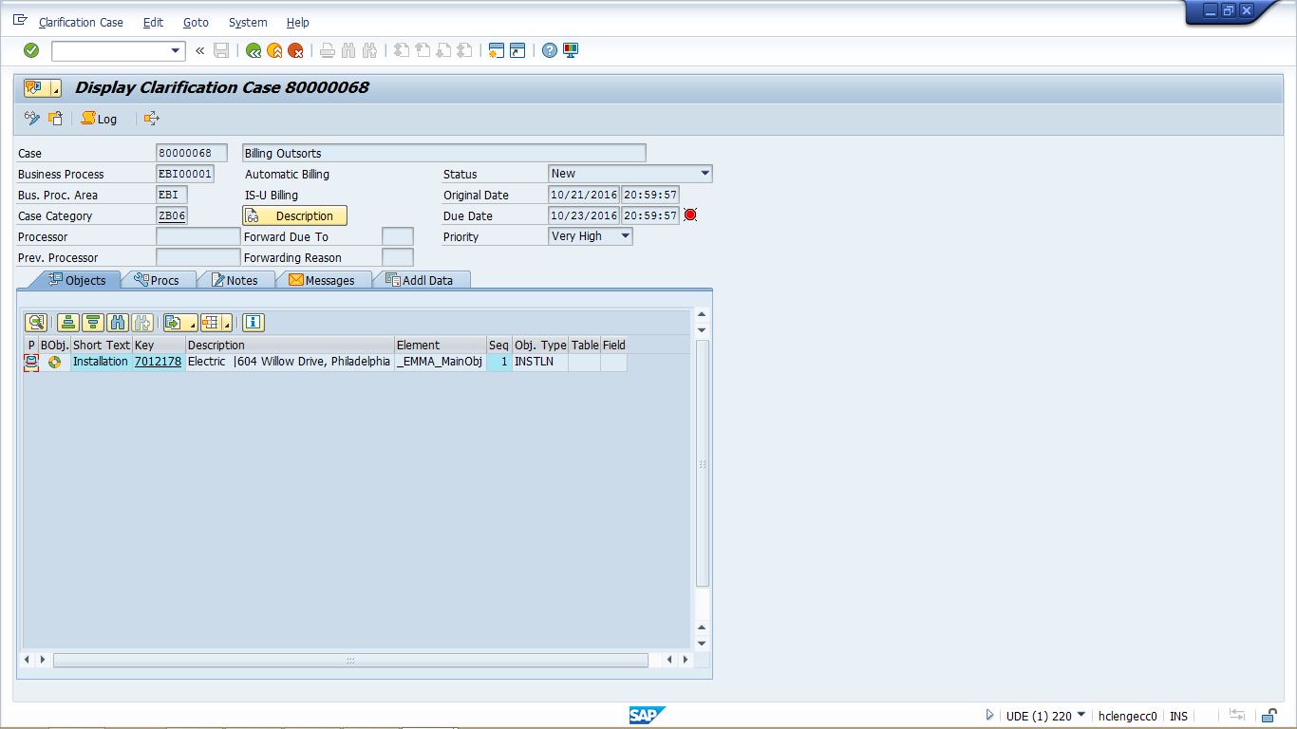
Figure 9: BPEM Case

Authorized users will be able to subscribe to a BPEM case using BDEx Watch List functionality, when BPEM case is completed, the subscriber will get an email notification. Refer BPD EM-02 - Exception Work Views for more information.
A user can subscribe to a complaint BPEM case. This user will be alerted when the complaint BPEM case is completed.

CPUC Complaint
A complaint filed by the CPUC can be formal or informal. Formal complaints are received directly from the CPUC to SCE’s Regulatory Operations team and are handled by an attorney in SCE’s Case Administration. Informal complaints are downloaded daily from a secure CPUC website by Consumer Affairs or received by phone call or email from the CPUC.
A BPEM case will be created in SAP Hybris C4C therefore entering CPUC Complaints into the Regulatory Information Management System is no longer required. By creating a BPEM case for a CPUC Complaint in SAP, there is a clear visibility in SAP for all types of complaints created. SCE will continue to submit the outcome/response to the CPUC via their system of record (currently CIMS).
It is necessary to identify a CPUC Complaint as formal or informal as they have different handling procedures as outlined in the SCE Business Process Article 4. To handle the differentiation, there will be three BPEM Case complaint categories configured. First is ‘Complaint - CPUC Dispute - Informal’ and second ‘Complaint - CPUC Dispute – Formal’ and third is ‘Compliant – CPUC Dispute – Phone Call’. User will create the BPEM cases with careful selection of category. (NOTE: CPUC reference number will be documented in the BPEM case long text for reference)
When the complaint is closed in the CPUC Customer Information Management System (CIMS) the BPEM CPUC Dispute will have to be closed by the user manually.
The CPUC Complaint BPEM case data can be exported to a file format via S/4HANA BDEx BPEM Summary Report. The user can edit the information in the exported file before sending to CPUC.
An Activity Type ‘Complaint’ will be created by a user manually via Hybris C4C’s Activity functionality and the BPEM case number will be documented manually by user in the Activity.

Local Public Affairs
Complaints can be filed by Local Public Affairs via Local Public Affairs (LPA) or BCD Account Executive Managers (AEM). A BPEM Case category ‘Complaint - Local Public Affairs’ will be created by a LPA user manually to be worked on by Consumer Affairs user who attends to the complaint. . An Activity type ‘Complaint’ will be created by user manually via Hybris C4C on the account documenting the complaint detail. When complaints raised to BCD Account Managers are resolved no other transaction is required. If the complaint needs to be escalated, the Account Manager will create a Ticket in Hybris C4C to be routed to their manager for resolution.

Executive Complaint
An Executive Complaint is related to a complaint from BP about an experience they have had with SCE and the customer has communicated to an SCE executive or Board of Directors through email, phone call, LinkedIn, written correspondence, etc. The user will either create a BPEM case category of the issue type, (i.e. ‘Complaint - Executive’) and BPEM case will be routed to Consumer Affairs team to resolve the issue or the business analyst in Consumer Affairs will receive the direct correspondence through the Executive process and create the BPEM directly.. Once the issue is resolved, Consumer Affairs team will update, close the BPEM case. User will create an Activity type ‘Complaint’ by user manually via Hybris C4C documenting the issue reported by the BP. Some executive complaints will be directed to CS Information Governance team due to potential non-compliance with TCPA or CANSPAM regulations. There are many reasons customers complain to SCE / EIX executives / Board of Directors. BPEM routing depends on the complaint type.

Social Media Inquiries
Inquiries/Complaints from BP via social media such as Twitter, Facebook and Yelp (or other future channels via social networks) are being handled by the Consumer Affairs team. The Consumer Affairs team will conduct the investigation by looking at the BP’s account. Activity type ‘Complaint’ will be created by the user manually via Hybris C4C, or through the BDEX process (depending upon what system of record the Consumer Affairs team works out of) at the BP account when the inquiry/complaint is attended by Consumer Affair team.
Media Relation hotline handles Media Inquiry from customer. A BPEM will be created in Hybris C4C via Ticket by them if the issue needs to be referred to Consumer Affairs team.

CCA/DA
When there is complaint related to CCA/DA, Front Office user will create a Ticket ‘Complaint – CCA/DA’. If issue is unable to be resolved, Front Office user will create a BPEM case category ‘Complaint – CCA/DA’ via Ticket to Customer Choice Services.

General Front Office Complaint

SCE.COM or Mobile App is down
Front Office user will transfer the call to CCC Tier 2 when customer is experiencing issue with SCE.COM or Mobile App. If CCC Tier 2 is unable to resolve the issue, the CCC Tier2 will create a Remedy ticket outside of SAP and assign to SCE IT. An Activity will be created by the user.

Force onto eBill
If BP requests to opt out of eBill, the CSR is able to turn off this feature by removing the indicator via Hybris C4C FOP (tcode CAA2) and the BP will get a paper bill on next billing cycle. Refer to BPD CIM-CS-07 Handle Bill Inquiries for more information.
An Activity type ‘Complaint’ will be created by user manually via Hybris C4C documenting the request/complaint detail and resolution.

Program Related Complaint
The BP will file a Program Related Complaint. The user attends to this complaint and updates the BP’s program accordingly via Hybris C4C. Refer to BPD PP-CS-02-Program Enrollment and Delivery, De-Enrollment & Decommission Programs for more information. An Activity type ‘Complaint’ will be created by user manually via Hybris C4C documenting the complaint filed by the BP.

Correspondence Inquiries / Complaints
A Complaint from BP could come from a Marketing Campaign Reply card, monthly bill, etc. Depending on the type of the complaint, a Ticket will be created by user. Depending on the issue topic, the user may create a BPEM case category ‘Complaint – Other Correspondences’ and Consumer Affair will attend to the BPEM. A Ticket or a BPEM Case is not required if the user is able to resolve the issue.
Activity type ‘Complaint’ will be created on Account documenting the complaint filed from BP.

Field Personnel and Employee
Complaint from BP can be on field personnel, SCE employee or SCE Contractor/vendor or anyone representing SCE. A ticket will be created and assign to employee’s supervisor or user that handles SCE complaints for these specific areas.

Trade Professional
Complaints from a BP can be related to the Trade Professional, or from a Trade Professional about SCE. Front office user will create a Ticket ‘Trade Professional’ to BCD and an Activity in C4C documenting the complaints for the BP or Trade Professional.

CS Information Governance (CSIG)
Complaints from a BP can be related to the Solar/3rd Party, Bill Scams/Fraud, Privacy and Misc. The user will create a BPEM case via Ticket to track the complaint.
Each type of CSIG complaint will have additional information that needs to be captured by the user. The user will navigate to Hybris C4C Survey Question Bank to obtain the additional information to be captured in the Ticket (Figure 10). The user will copy the entire block of information (Figure 11) and paste the information into Ticket long text. The user will read out each question to the customer and capture the answers in the Ticket long text. The long text captured in the Ticket will be copied to BPEM long text automatically. If the user is going to use C4C FOP to create BPEM Case, user will copy the entire block of information and paste it into BPEM long text.

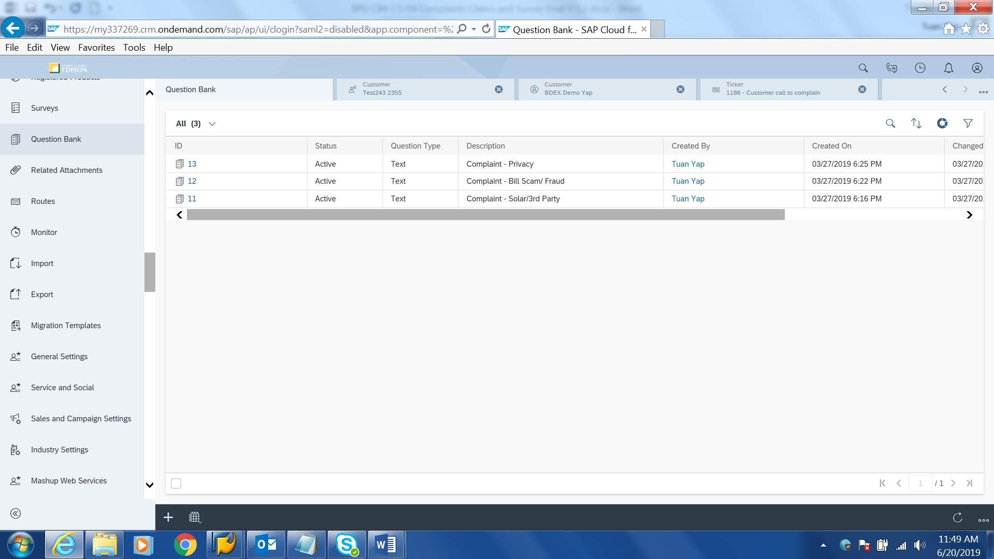
Figure 10: CSIG complaint

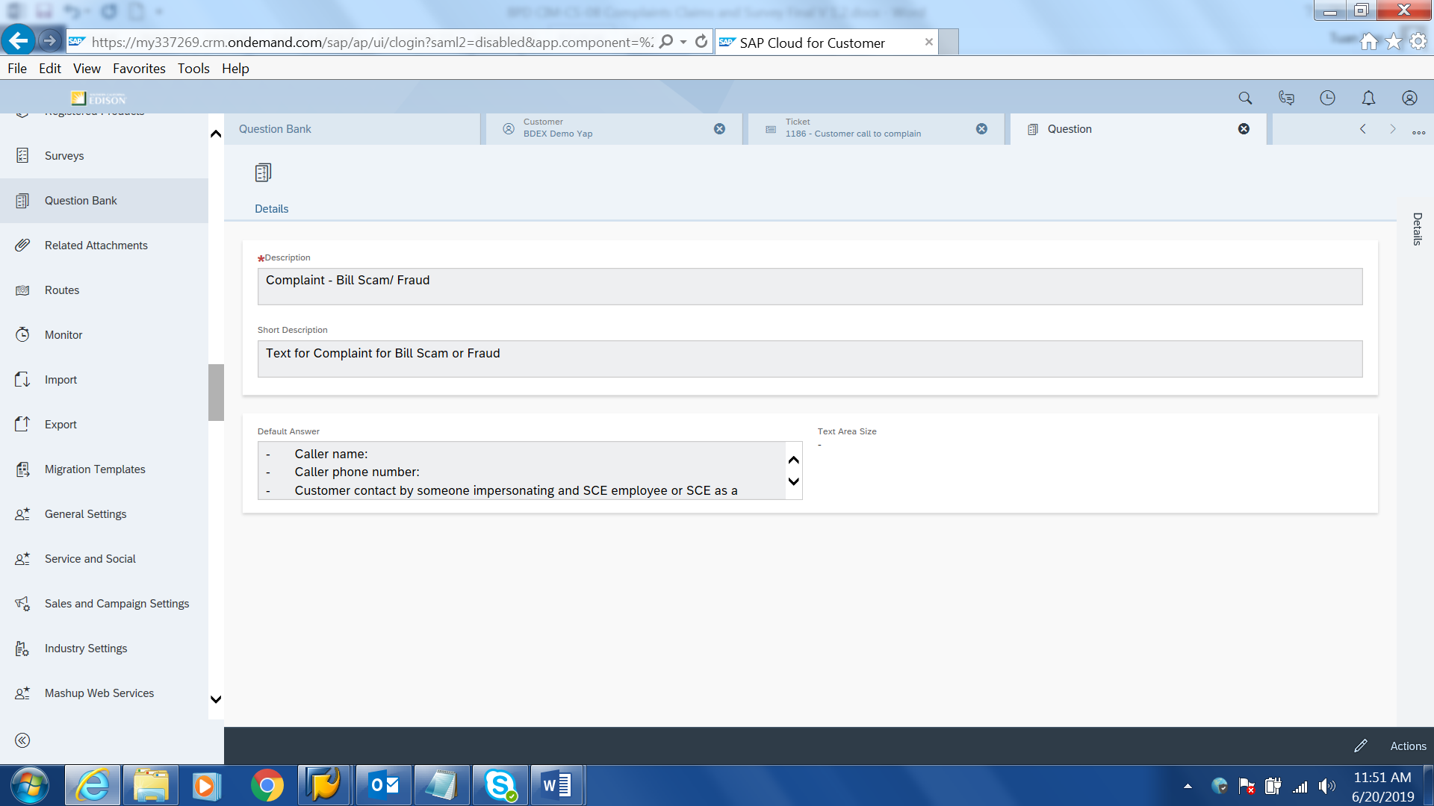
Figure 11: CSIG complaint additional information

The user will also create an Activity in C4C documenting the complaints from the BP.
If CSIG needs to refer an issue to Consumer Affairs team, CSIG will reassign the BPEM case to Consumer Affairs team to work on.

Solar/ 3rd Party
Complaints from a BP can be related to solar companies or other 3rd parties acting on behalf of the BP without the BP consent. The user will create a BPEM case ‘Complaint – CS Governance’ and be routed and worked by the CS Information Governance team. Additional information will need to be captured for Solar/3rd Party. The user will navigate to Hybris C4C Survey functionality and initiate the Survey titled ‘Complaint - Solar/3rd Party’. The list of additional information that is required to be captured in Solar/3rd Party will be shown in the survey. User will ask the BP the list of questions in the Survey and document the answer from the BP in the long text. The information in the survey is as below:
- Caller name:
- Caller phone number:
- 3rd party company name:
- 3rd party specialist name:
- 3rd party phone number:
- 3rd party accessed customer’s confidential account info?:
- Did 3rd party create a ‘My Account’?:
- Unauthorized my account email address:
- Unauthorized my account email address is deactivated?:
- Customer provided solar company SCE A/C # or copy of bill?:
- Did you note the account at the customer level?:
- Provide any other details about the call:
- What action took place: -
  - My Account created:
  - Impersonated a customer:
  - Use of emergency help line:
  - Use of SCE logo/ name/ impersonate SCE rep:
  - Inappropriate sales practices:
User can copy the entire information in the survey and paste into the BPEM case long text to ensure no information will be missed.
Other information that is required when a BP reports Solar/3rd party issue such as Account number can be identified in the SAP object – Contract Account. Date BP reported incident to SCE, approximate time to call is the creation date and time of the Ticket.
An Activity type ‘Complaint’ will always be created by user manually via Hybris C4C on the BP account documenting the complaint details.

Bill Scam/Fraud
When a fraud case is reported by a BP, the user will create a BPEM case ‘Complaint – CS Information Governance’ and be routed and worked by the CS Information Governance team. Additional information will need to be captured for Fraud BPEM cases. The user will navigate to Hybris C4C Survey functionality and initiate the Survey titled ‘Complaint – Bill Scam/Fraud’. The list of additional information that is required to be captured in Fraud will be shown in the survey. The user will ask the BP the list of questions documented in the Survey and document the answer from the BP in the long text. The information in the survey is as below:
- Caller name:
- Caller phone number:
- Customer contact by someone impersonating and SCE employee or SCE as a company:
- Impersonator name:
- Impersonator phone number:
- Caller ID phone number
- How much was customer asked to pay:
- Customer made payment (Yes/No):
- Where was the customer directed to go make payment:
- Method of payment:
- Credit card number:
- Law enforcement if contacted by customer:
Other information that is required when the BP reports fraud such as Account Holder Name, Residential or Commercial Account can be identified in the SAP object – BP master and Contract Account.
An Activity type ‘Complaint’ will always be created by user manually via Hybris C4C on the BP account documenting the complaint details.

Privacy
When a concern of privacy is reported by the BP, the user will create a BPEM case ‘Complaint – CS Information Governance’ and will be routed and worked by the CS Information Governance Team. Additional information will be captured when the Privacy is initiated. User will navigate to Hybris C4C Survey functionality and initiate the Survey titled ‘Complaint - Privacy’. The list of additional information that needs to be captured in Privacy will be shown in the survey. The user will ask the BP the list of questions that is documented in the Survey and document the answer from the BP in the long text. The information in the survey is as below:
- Caller phone number:
- Specialist name:
- 3rd accessed to customer’s confidential account information?:
- What data privacy incident(s) have you identified: -
  - Someone else’s information is being sent in error
  - Someone is accessing the customer’s account without their permission
  - Other (please specify)
- Source of the data incident (Phone, Letter, SCE.COM):
- Has customer previously contacted SCE?:
- Brief description of why you think this call was a data incident:
Other information that is required for privacy such as Account number can be identified in the SAP object – Contract Account. Date BP reported incident to SCE, approximate time to call is the creation date and time of the Ticket.
An Activity type ‘Complaint’ will always be created by user manually via Hybris C4C documenting the complaint details.

Escalated Call Handling

Tickets will also be used to document the call escalation process within the CCC or BCD. If the CCC employee is unable to resolve the customer request or needs assistance to resolve the call, they will create a Ticket to their Lead. The Lead will provide the necessary guidance to the employee to resolve the call, resolve the call themselves with the caller or escalate the call to their Supervisor. If the Supervisor is unable to resolve the call, then at that point it may be escalated to another department or manager to resolve the call. Each employee who works on the escalated call will document their actions manually within an Activity record via Hybris C4C. BCD will leverage a similar process to escalate business customer issues within their organization.
All Tickets and BPEM cases created related to the call escalations will be reportable by leveraging self-service reports.
Escalated calls can include high bill disputes, Move In/Out disputes, Do Not Call, program related concerns, etc.

Process / Performance Improvement
- Single System or interfaces to provide a 360 degree view of the compliment via SharePoint and complaint via Ticket or BPEM case
- BPEM case is able to track the complaint from the moment it is logged till it is completed.

Prerequisites and Inputs
To create a BPEM case in Hybris C4C, it can be created via Ticket. BPEM can be created via C4C FOP as well.
A request to create a Complaint should require the following information:
- BP number is required when creating a complaint BPEM case for BPEM Case created from Ticket. Other SAP objects such as Contract Account, Contract, Premise etc can be used as SAP object to create BPEM Case via FOP.
- BP number is required when creating an Activity.
- Premise information is required when creating a Service Order.

General Assumptions
- Medallia will continue to be used to send surveys
- Medallia will continue to consolidate and host survey response such as After Call Survey and Voice or Customer. Mediallia will also continue to be used to generate statistical report on survey response.
- Data that is currently extracted from DB2 (IVR) and SCE.COM will continue to be sent to Medallia to send survey to customers
- SCE will continue to use SharePoint to capture request for employee recognition program such as Customer Hero, Exception Neighbor and Star Behavior. The program in recognizing an employee remains unchanged.
- Claims will be handled outside of SAP
- Consumer Affairs and CS Info Governance will be the primary user of the Complaint Tickets. Other departments like CCC and BCD will use the work flow tickets to manage their work.
- Consumer Affairs team and Customer Choice Services will have access to BDEx to work on BPEM cases that assigned to them
- BCD Voice of Customer survey data will remain a manual report from BW and sent to CP&S for survey reasons

Business Process Hierarchy
This Business Process Hierarchy provides a listing of all scenarios/business processes, sub-processes, and SAP Transaction codes identified to support this process.
Level 1 | Level 2 | Level 3 | Level 4
FO | Complaint | Create Ticket/BPEM case | Hybris C4C
FO | Complaint | Change Ticket | Hybris C4C
FO | Complaint | Display Ticket | Hybris C4C
FO | Complaint | Create BPEM case | C4C FOP
FO | Complaint | Change BPEM case | EMMAC2
FO | Complaint | Display BPEM case | EMMAC2
FO | Complaint | Create Activity | Hybris C4C
FO | Complaint | Change Activity | Hybris C4C
FO | Complaint | Display Activity | Hybris C4C
BO | Complaint | Manage work queue in BDEx Dynamic Work Center | /BTI/BWC
BO | Complaint | 360 view of BP activities and cases in Customer Centric Hub | /BTI/BDEX

Process Flows
This BPD will cover Create Complaint and Manage Complaint. Each subsection where the process is detailed will have a process flow diagram for that process and a table detailing the steps that are taken within that process including processes handled outside of SAP.

Create Complaint
This process flow describes the process to create a complaint.

Process Flow Diagram

Process Flow Steps

Step | Description of Step | Hybris C4C / T-Code | Role(s) | If step is relevant for a Control, add Requirement  ID
10 | Customer complaint via phone  Customer file a complaint to SCE via phone. | N/A | N/A
20 | Customer complaint via SCE.COM, Web chat, Social Media  Customer file a complaint to SCE via SCE.COM, Web chat and Social Media (Twitter, Facebook and LinkedIn) | SCE.COM | N/A
30 | Customer complaint via email & US mail  Customer file for a complaint to SCE via email and US mail. | N/A | N/A
40 | CPUC complaint  CPUC file a complaint to SCE via Regulatory Information Management System.  Government file a complaint to SCE via LPA/BCD AEM. | N/A | N/A
50 | Correspondence Inquiry  Customer complaint/inquire about the correspondence. | N/A | N/A
60 | Local Public Affairs & CCA/DA complaint  Local Public Affairs file a complaint to SCE via LPA/BCD AEM or complaint about CCA/DA. | N/A | N/A
70 | Debris or Outage related?  If complaint is debris or Outage related, go to step 120.  Otherwise, go to step 90. | N/A | N/A
80 | Bill Scam/Fraud, Solar/3rd Party, Fraud, Privacy related?  If complaint is Bill Scam, Solar/3rd Party, Fraud, Privacy related, go to step 150.  Otherwise, go to step 90. | N/A | N/A
90 | eBill related?  If BP complaints about account is defaulted to eBill and wanting to receive paper bill, go to step 140.  Otherwise, go to step 100. | N/A | N/A
100 | Executive complaint, CPUC, Local Public Affairs related?  If complaint is Executive complaint, CPUC or Local Public Affairs related, go to step 160.  Otherwise, go to step 110. | N/A | N/A
110 | SCE.COM/Mobile, Correspondence Inquiry, Employee related?  If complaint is related to SCE.COM/Mobile, Correspondence Inquiry and employee related, go to step 180.  Otherwise, go to step 200. | N/A | N/A
120 | Create Service Order  User selects the specific Order Code to create a Service Order. Service Order will be routed to the Field Personnel to work on. | Hybris C4C | Creating Complaint User
130 | Create Ticket and/or BPEM case  Create Ticket and or BPEM case for CSIG complaints. | Hybris C4C | Creating Complaint User
140 | Update eBill flag  If BP complaints about account is defaulted to eBill and wanting to receive paper bill, CSR will remove eBill flag from BP Account. | Hybris C4C | Creating Complaint User
150 | Create Activity  User creates Activity Record documenting the Work Order or CSIG complaint or BPEM case reference number and the detail of the complaint | Hybris C4C | Creating Complaint User
160 | Create BPEM case  User selects the specific BPEM case category to create a BPEM case. BPEM case will appear in the work queue for a specific work group to be worked on. | Hybris C4C | Creating Complaint User | Control CS-1165 & Control CS-1185
170 | Create Activity  User creates Activity Record documenting the Work Order or BPEM case reference number and the detail of the complaint | Hybris C4C | Creating Complaint User
180 | Create Ticket  User selects the specific Ticket category to create a BPEM case. Ticket will be assigned to specific employee to work on. | Hybris C4C | Creating Complaint User
190 | Create Activity  User creates Activity Record documenting the Work Order or BPEM case reference number and the detail of the complaint | Hybris C4C | Creating Complaint User
200 | End

Manage Complaint
This process flow describes the process in managing complaint.

Process Flow Diagram

Process Flow Steps

Step | Description of Step | Hybris C4C / T-Code | Role(s) | If step is relevant for a Control, add Requirement  ID
10 | Complaint is created  Complaint is created in SAP. | Hybris C4C | N/A
20 | BPEM case created for complaint?  If BPEM case is created for the complaint, go to step 50.  Otherwise, go to step 40. | N/A | N/A
30 | Service Order created for complaint?  If Work Order is created for complaint, go to step 90.  Otherwise, go to step 40. | N/A | N/A
40 | Ticket is created for complaint?  If Ticket is created for the complaint, go to step 120. Otherwise, go to step 160. | N/A | N/A
50 | Attend to Complaint  User attends to BPEM case for complaint. | /BTI/BWC | Managing Complaint user
60 | Complaint is resolved?  If complaint is resolved, go to step 70.  Otherwise, go to step 50. | N/A | Managing Complaint user
70 | Close BPEM case  User documents the complaint resolution in the BPEM case long text and update BPEM Case status to ‘Closed’. | /BTI/BWC | Managing Complaint user
80 | Close Ticket  Ticket associated with the BPEM case is closed. | Hybris C4C | Managing Complaint user
90 | Attend to Work Order  User attends to the Work Order and goes to the premise. | IW32 | Managing Complaint user
100 | Complaint is resolved?  If complaint is resolved, go to step 110.  Otherwise, go to step 90. | N/A | Managing Complaint user
110 | Complete Service Order  User document the complaint resolution in the Work Order long text and update Work Order status to ‘Completed’. | IW32 | Managing Complaint user
120 | Attend to Ticket  User attends to the Ticket for complaint. | Hybris C4C | Managing Complaint user
130 | Complaint is resolved?  If complaint is resolved, go to step 140. Otherwise, go to step 150. | N/A | N/A
140 | Close Ticket  Ticket is closed. | Hybris C4C | Managing Complaint user
150 | Create BPEM case  Create a BPEM case via Ticket. | Hybris C4C | Managing Complaint user
160 | End

3rd Party and SCE Legacy System Integrations

3rd Party or SCE Legacy System Integration | Description of Integration and Required Change to 3rd Party or SCE Legacy System | Estimated Complexity of 3rd Party or SCE Legacy system change
IVR (DB2 & Genesys) and SCE.COM | Survey response from IVR and SCE.COM are downloaded to Medallia for report generation. | High

Data Elements
The information that will be captured for the Complaint (either as part of migration or in the course of normal processing) will be defined in this BPD.

Create Complaint BPEM case
The following data elements will be used by the BPEM case creation for complaint in Hybris C4C.


Field | Type | Comments
Case category | Required | Complaint type
Work Description | Optional | BPEM case long text

Edit Complaint BPEM case
The following data elements will be used by the BPEM case Edit for complaint in Hybris C4C.
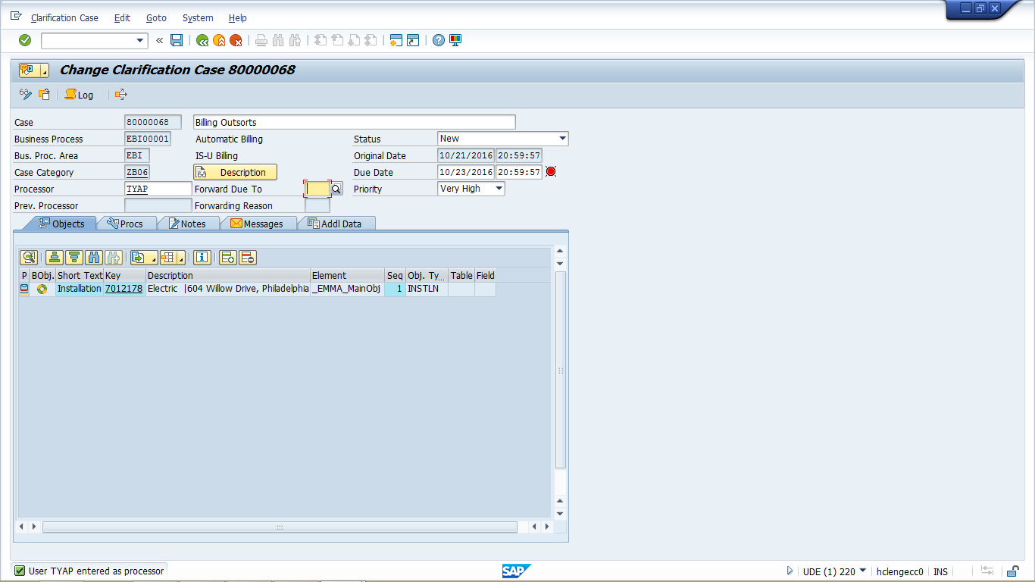

Field | Type | Comments
Case number | Required | BPEM case number
Status | Required | Status of the BPEM case
Priority | Required | Priority of the BPEM case
Due Date | Required | Due date of the BPEM case
Due Time | Required | Due time of the BPEM case
Processor | Required | Person assign to work on the BPEM case
Forward Due To | Optional | Required only when the BPEM is reassigned from one person to the other person. This contains forwarding reason.

Create Activity
The following data elements will be used by Activity creation in Hybris C4C.

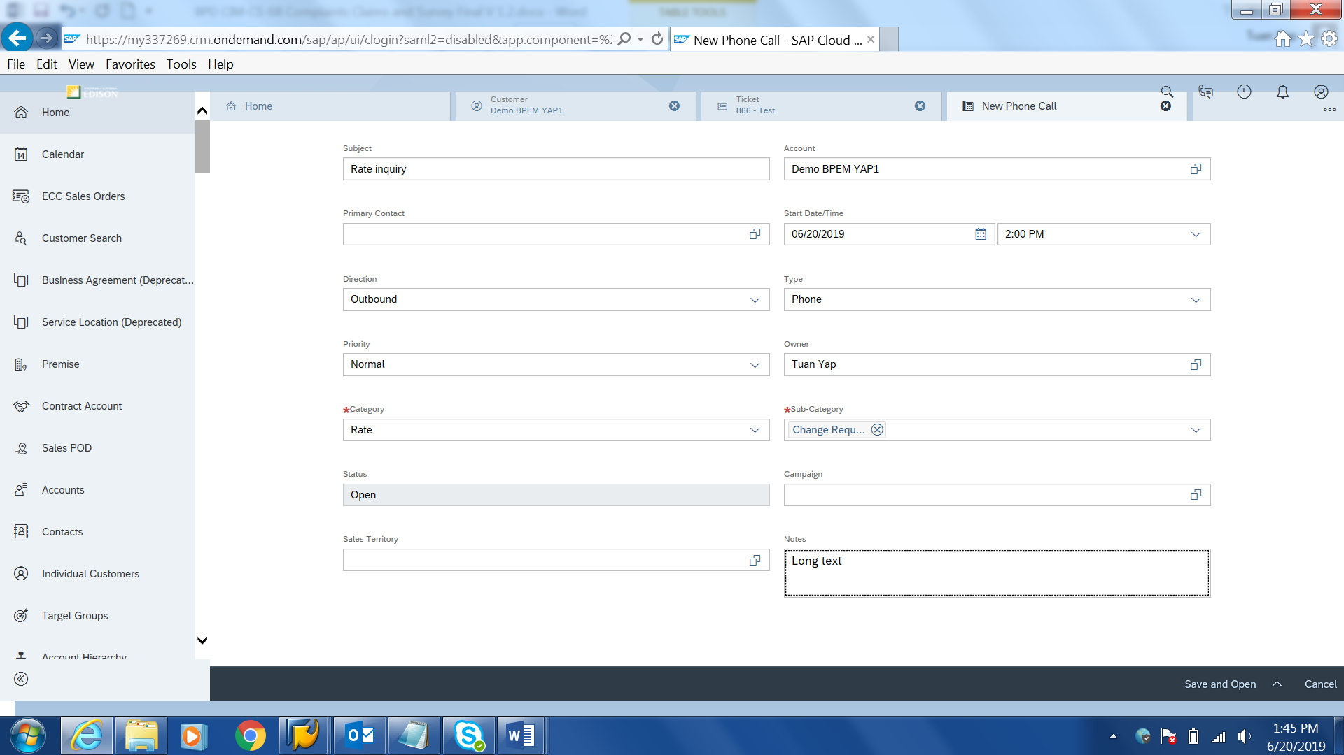
Field | Type | Comments
Subject | Optional | Description of the activity
Account | Display | BP name
Primary Contact | Optional | Primary Contact person name
Start Date/Time | Optional | Start Date/Time of the Activity
Direction | Required | Channel. Eg. Inbound, Outbound
Category | Required | Category of an Activity
Sub Category | Optional | Sub category of an Activity
Priority | Required | Priority
Status | Display | Status
Owner | Required | Creation user name
Campaign | Optional | For Territory Management use only
Sales Territory | Optional | For Territory Management use only
Notes | Optional | Activity long text

Create Ticket
The following data elements will be used by Ticket creation in Hybris C4C.
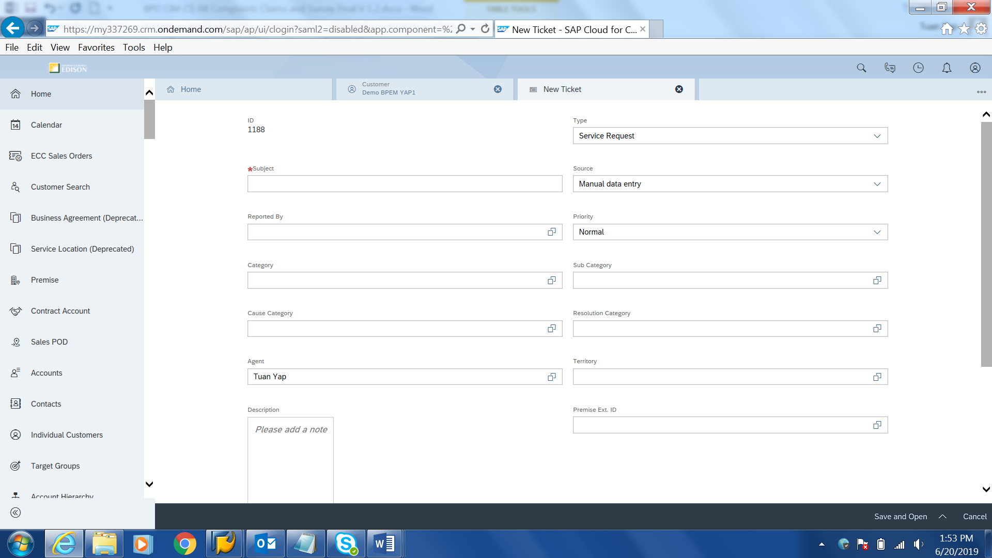

Field | Type | Comments
ID | Display | Ticket number
Type | Mandatory | Type of Ticket.  ‘Service Request’ will be defaulted.
Source | Mandatory | Channel used to create ticket.  ‘Manual Data Entry’ will be defaulted.
Employee | Optional | Person the ticket is assigned to
Service Category | Mandatory | Category of the Ticket
Cause Category | Optional | Sub category of the Ticket
Priority | Optional | Priority of the Ticket
Agent | Display | Person that created the ticket
Subject | Mandatory | Title of the Ticket. Free text field.
Description | Optional | Long text of the Ticket
Reported by | Optional | The person that reported the issue

    - Source Systems and Data Volumes
- Customer complaints handled:
  - 4050 in 2015
  - 4919 in 2016
  - 4883 in 2017

- Customer claim handled:
  - Average of 12,854 claims a year

Cloud for Customer (Hybris C4C) Integration

Processes
- Ticket and BPEM case creation for complaint can be done via Hybris C4C views
- BPEM case can be created via C4C FOP.
- BPEM case change and display view will be available for user via Hybris C4C FOP.
- Activity record create, change and display view will be available for user via Hybris C4C views.
- Service Order creation and display will be available for user via Hybris C4C views.

Activity Records
Refer to Customer Interaction BPD Call Disposition Type & Sub Type.

Service Order
The following activities will result in a Service Order to be created:
- Complaint from BP on debris or mess left by field personnel
- Outage reported from BP

Exception Management Requirements
This section outlines a high level description of each BPEM Case or other user workflow items (such as “Tickets” used by Front Office) used to route work requests between business areas. The companion document for this section which outlines the detail of each case is documented in APSE on the Exception Case Template General Document #8.

User Exception Scenario / Description | User Group | Initiated by | Work Distribution
Refer to attached worksheet.

Process Risks and Mitigation

Risk Statement | Mitigation
N/A

Key Performance Indicators
The following have been identified as KPI’s at Southern California Edison, along with the means of measuring each KPI and the current measurement statistic for each KPI:
Measured KPI | Description | Measurement Method | Current Statistic
Complaint Resolution | Maintain < 10-day turnaround for escalated complaints | N/A | N/A
Customer Satisfaction (SCE & GC Services Blended) | > 90% (measured by the ACS) | N/A | N/A
G-4 AB&G Satisfaction for S1 Customers ‐ Achieve ≥72% | N/A | N/A | N/A
G‐5 BCD Channel Satisfaction for S1 Customers ‐ Achieve ≥82% | N/A | N/A | N/A
SCE CSR Quality Assurance | >90% (measured by QA scores) | N/A | N/A
GCS Quality Assurance | >90% (measured by QA scores) | N/A | N/A
JD Power | Maintain 2nd Quartile | N/A | N/A
Customer Satisfaction (JD Power) Scores | Target: 2nd Quartile | N/A | N/A
SCE.com satisfaction | Target: > 66 | N/A | N/A
VOC – Ease of Experience | Voice of the Customer measurement (measured on survey) | N/A | N/A
Call Quality Monitoring | Call monitoring QA score based upon agreed upon call standards. | N/A | N/A
Issues | Number of issues raised with Customer Issues Management | N/A | N/A
IVR - Customer Satisfaction | Customer satisfaction with IVR | N/A | N/A
PUC Complaints | Number of Public Utility Commission complaints | N/A | N/A

Key Metric Definition
The following have been identified as key metrics at Southern California Edison that require business rule for calculation:
Key Metric | Description | Business Rule | Reference
N/A

Controls, Regulatory Rules, and Security
Requirement  ID (from RTM) | “As-Is” Control Requirement | “To Be” Risk Statement | “To-Be” Control Activity” | Control Automation (manual, IT dependent- manual, automated | Relevant technical identifier or RICEFW reference
CONTROL-CS-1165 | Expedited Complaint Procedure for Community Choice Aggregators (CCAs): SCE shall apply the expedited complaint procedure defined in Rules 24 through 29 ("Rules Regarding Enforcement Procedures") of the Code of Conduct and Expedited Complaint Procedure to complaints filed by Community Choice Aggregators (CCAs) against electrical corporations, including complaints alleging violations of the rules adopted in this decision. The Code of Conduct and Expedited Complaint Procedure pertaining to the consideration, formation and implementation of CCAs is included as Attachment 1 of this Decision, D.12-12-036. (See OP 3 of D.12-12-036). | Noncompliance or misinterpretation with regulatory and legislative requirements may lead to misstatements of financial statements, penalties, fines and/or prosecution | Whenever a BPEM case is created to document a CCA complaint, the Customer Choice Services Sr. Analyst logs the complaint in the CCA Log and tracks the CCA Complaint until resolved. The Sr. Analyst is also able to track the resolution status for “Expedited” CCA complaints via reports. (“Expedited” Complaints are validated complaints versus just inquiries. | ITDM – IT Dependent Manual | N/A
CONTROL-CS-1185 | Maintain Log of All Community Choice Aggregator (CCA) Complaints: SCE shall maintain a log of all new, resolved, and pending complaints submitted in writing relating to services provided for the Community Choice Aggregator (CCA) and CCA customers. The log shall be subject to review by the CCA and the Commission, and shall include the date each issue was received; the customer's name, address, and Service Account ID number if the issue is in relation to a specific customer; a written description of the complaint; and the resolution of the complaint, or the reason why the complaint is still pending. See Rule 21 of The Code of Conduct and Expedited Complaint Procedure pertaining to the consideration, formation and implementation of Community Choice Aggregators (CCAs). (D.12-12-036, OP1 and Attachment 1, p. A1-9). | Noncompliance or misinterpretation with regulatory and legislative requirements may lead to misstatements of financial statements, penalties, fines and/or prosecution | Whenever a BPEM case is created to document a CCA complaint, the Customer Choice Services Sr. Analyst logs the complaint in the CCA Log and tracks the CCA Complaint until resolved. The Sr. Analyst is also able to track the resolution status for “Expedited” CCA complaints via reports. (“Expedited” Complaints are validated complaints versus just inquiries.) | ITDM – IT Dependent Manual | N/A

Security Considerations
Role | Transaction Code (T-Code) | T-Code Description | Functional Restriction | Organizational Restriction
Consumer Affairs | /BTR/PP_ASTROLABE (tcode to run the report)  /BTR/PP_SUM (tcode to display the report) | Customer Centric Hub | Display
Consumer Affairs | n/BTI/BWC | BDEx Dynamic Work Center | Display
Consumer Affairs | EMMAC2 | BPEM case | Change
CCC, GS Services, BCD, RSO, Consumer Affairs, LPA | Hybris C4C  Ticket  & FOP | BPEM case creation | Create
CCC, GS Services, BCD, RSO, Consumer Affairs | Hybris C4C | Service Order creation | Create
CCC, GS Services, BCD, RSO, Consumer Affairs, LPA | Hybris C4C | Service Order display | Display
CCC, GS Services, BCD, RSO, Consumer Affairs, LPA | Hybris C4C FOP - IW38 | List of Service Order created | Display
All Users | Hybris C4C Activity | Create Activity | Create
CCC, GC Services, BCD, RSO | CAA2 | Contract Account – remove eBill field | Change

Custom Program/Transaction Codes
Please identify any custom programs/transaction codes that need to be developed for RICEFW objects.
- Is the custom program executed in the batch mode or dialogue mode
- Is the custom program assigned to an authorization group
- What is the custom transaction code for the custom program
- Should there be an authorization check made against any field in the custom program/custom t-code and if so what is the custom/standard authorization object used(For example does it have to be restricted to residential vs commercial customer)
- Does the custom programs/custom t-codes have any crictial or sensitive customer information that needs extra security
Custom Table | Authorization Grp Assigned | Custom T-code for the Table | Table Access (display/update) | RICEFW Reference ID
N/A

Custom Table/Transaction Codes
Please identify any custom tables/transaction codes that need to be developed for RICEFW objects.
- Are there any customer sensitive/critical Z tables created
- What is the authorization group assigned to the table
- Is it just a maintenance or display only table
- What is the Z transaction code for the custom table

Custom Table | Authorization Grp Assigned | Custom T-code for the Table | Table Access (display/update) | RICEFW Reference ID
N/A

Data Criticality and Cybersecurity Baseline Risks
Specify Data Classification /Special Handling or Regulatory Requirement  What is the classification of Data? Does it trigger any special regulations?  Please select the classification / Sensitivity of the Data. This will help us Assess the Risk associated and remediation measures if any. | <Select all that apply>  ☒ PII - Personal Identifiable Information / Privacy Law  ☐ CEII - Critical Energy Infrastructure Information  ☐ FERC SOC (Standards of Conduct)  ☐ NERC CIP Confidential  ☐ Sarbanes-Oxley (SOX) financial reporting data  ☐ SCE utility data accessible by affiliate companies (CPUC)  ☐ PCI - Payment Card Industry Compliance  ☐ Customer Information Service Request (CISR, CISR-DRP)  ☐ Other _<Please Specify>_  ☒ Internal  ☒ Public  ☐ Confidential
Please identify which business Group/Role will require access to the data and/or solution:  Please select the list of Busines Groups will have access to this Data / Process. This will help us Determine the Impact and Risk Spread. Will ensure efficient Risk mitigation measures. | <Select all that apply>  ☒ SCE Customer, Res./Comm. Customer;  ☒ SCE OU, Business Function Organization Name:  ☐ Vendor  ☐ External business partner(s) & SaaS providers  ☐ External on-shore contractors  ☐ External off-shore contractors  ☐ SCE Affiliate Company Employees  ☐ SCE Employees, specify if they have Marketing Function responsibilities (e.g., ES&M)  ☒ SCE contract workers  ☐ Regulatory Agencies  ☐ Others _<Please Specify>_
How many of the SCE Customer, Employee, Vendors will use or affected by the Business Process?  To identify the Impact if services are adversely affected. | 100  100 - 1,000 Approximately  1,000 - 10,000  10,000+…..
How much Information/data would be processed, received or tramitted by the Business Process?  The data volume that will be utilized by this process. Helps us in determining the Impact and criticality | 100 MB / GB  100 - 1,000 MB / GB Approximately  1,000 - 10,000 MB / GB  10,000+ MB / GB…..
Number of business transactions in average?
These are the number of transactions process by the application on average. The number of transactions help in understanding criticality and Impact.
Additional Security Consideration: | Any Cybersecurity impact in addition to SAP system security:  - Internet Facing Web Application? Yes  - Internet Facing Application Programming Interface? Yes  - 3rd party Fedrated Authentication & Authorization, Single Sign On?

Technical Considerations

4.1 RICEF-W Assessment
All of the Forms, Reports, Interfaces, Conversion items, Extensions/Enhancements and Workflows (RICEF-W) that have been identified for this BPD are detailed in the tables below and will represent the totality of all RICEF-W items documented at the time of sign-off of this BPD. Any RICEF-W items that are confirmed via change control after this BPD receives final sign-off, will be managed within Southern California Edison’s APSE environment and not within this document.

Reports
Report Name & Description (List Requirements met by this Report) | Complexity | Reference ID
Ability to provide Chrono/history of account from Service Orders and IRs from a report. | Medium | REP-CIM-S-08-01 Report for Service Order and IR long text
Provide all complaints and compliments by Organization and agent | Medium | REP-CIM-CS-08-01 Complaints and compliments by organization and user
Ability for system to generate a statistical report on survey response | Medium | REP-CIM-CS-08-01 Statistical report on survey response
Ability to generate a report on a survey response and comment | Medium | REP-CIM-CS-08-02 Report on survey response detail information
Ability for system to extract Transactions, Interaction activities of BPs and provide to Voice Of The Customer Survey Tool for random survey. Filter by date range and business rules | Medium | REP-CIM-CS-08-03 Report to extract BP Transactions & Interaction Activities to Voice of the customer survey tool

Interfaces
Interface Name & Description (List Requirements met by this Interface) | Complexity | Reference ID
Ability to route a caller back to IVR to complete the survey when the agent ends the call. | Medium | INT - CIM-CS-08-01 Route caller back to IVR to complete survey
Voice of the Customer Survey Tool shall interface with C4C to create Interaction Records for assigned business customers based on survey results | Medium | INT - CIM-CS-08-02 Voice of the customer survey tool to create IR in C4C
Ability for system to interface with Voice Of The Customer Survey Tool to send survey to Assigned Business customers based on business rules. | Medium | INT-CIM-CS-08-03 Send survey to Assigned non residential customer via Voice of the customer survey tool
The survey tool (3rd party tool) shall send a response to a designated employee based on business rule when the survey response is completed | Medium | INT-CIM-CS-08-03 Notify employee on a survey response
Ability for system to record if the BP has previously received a survey with detail such as transaction date, transaction type, 3rd party name & indicator (eg Voice Of The Customer Survey Tool) | Medium | INT-CIM-CS-08-04 Received and store survey data from 3rd party and store in SAP
Ability for the system to provide transaction reference attributes (activity id, work order id etc.) as part of the survey response | Medium | INT-CIM-CS-08-04 Third party to provide transaction reference attributes for survey response

Conversion
Conversion Name & Description (List Requirements met by this Conversion) | Complexity | Reference ID
N/A

Extension/Enhancements
Extension Name & Description (List Requirements met by this Extension) | Complexity | Reference ID
System to automatically default system date to end date on a complaint when the complaint status is closed or completed or canceled. User is able to overwrite the end date. | Medium | ENH-CIM-CS-08-01 Default End Date to BPEM
Ability for originator of note to edit own note for complaint (other users should not be able to edit someone else note) | Medium | ENH-CIM-CS-08-02 Ability for BPEM creator to edit BPEM long text
Ability to mark complaint notes and/or responses to be private or confidential | Medium | ENH-CIM-CS-08-06 Authorization control to update BPEM long text
Ability for system to automatically prevent a disconnect if a customer filed for designated complaints | Medium | ENH-CIM-CS-08-07 Credit related complaint to create dunning lock
Ability for the system to extract the data for reporting purposes for Voice Of The Customer Survey Tool (eg. Medallia)  Ability for the authorized user to modify the criteria for data extracts for survey purposes to Voice Of The Customer Survey Tool | Medium | ENH - CIM-CS-08-01 Download customer data from SAP
The system should be able to initiate a survey based on business rule | Medium | ENH-CIM-CS-08-05 Create survey based on business rules
BP should only receive a survey x time of the same type of transaction within a certain period | Medium | ENH - CIM-CS-08-02 Control on number of survey BP receives

Forms
Form Name & Description (List Requirements met by this Form) | Complexity | Reference ID
N/A

Workflows
Workflow Name & Description (List Requirements met by this Workflow) | Complexity | Reference ID
N/A

IDEX Considerations
N/A

Production System Cut-over Considerations
Complaint, compliment, claim and survey are not migrated over to SAP. They will remains stored in the legacy system. User will reference to the legacy system when BP calls SCE asking about complaint, compliment and claim created prior cut-over.

4.4 Other Considerations
N/A

Change Management

5.1 Change Impacts
Change Element Short Description | Change Impact Category | Audience Group(s) | Impact | Business Effort
A BPEM case can be issued to track and reports complaints related to solar/3rd party, bill scams/fraud, privacy, canned spam and TCPA. The BPEM case allows for follow up and visibility to the order until completion. Currently users completes a form in Portal that generates an email that goes to multiple parties. There is no visibility outside of a note regarding the outcomes of the skip tracer / fraud / compliance request. | Process,Benefit/  Improvement,Regulatory/  Legal (275) | CS-CSOD-CCC All,CS-BCD-All,CS-CSOD-Consumer Affairs, CS-CP&S-All | Low | Low
Users may create a ticket/BPEM case for all escalated calls following their internal process (eg. CCC process - lead and then can be forwarded to supervisor and then to manager prior to going to consumer affairs) for tracking purposes.  This process efficiency allows to for better tracking of all escalated calls. Notes can be updated if escalation is moved forward so that other people can view what has already been offered to the customer and what was discussed. Today, if agents are not able to locate a supervisor, a callback if offered. The callback request is an email that is sent to a shared inbox. There is no tracking visibility on the escalated call (e.g. completion, follow up, manager call etc.) unless the agent reviews the notes. | Benefit/Improvement  Process  Culture Shift (516) | CS-CSOD-CCC All;  CS-BCD-All;  CS-CSOD-Consumer Affairs;  CS-CSOD-RSO All | Medium | Medium
BPEM and ticket reporting capabilities may replace the use of databases to track and report on escalated volumes. Currently many organizations have databases to track and report escalations. The data that is manually entered is used for tracking volumes and types. SAP functionality will allow for visibility and multiple users can create reports as needed. | Benefit/Improvement;Culture Shift;Process (856) | CS-BCD-All;CS-CP&S-All;CS-CSOD-CCC All;CS-CSOD-Consumer Affairs | Medium | Medium
Non-escalated complaints related to data privacy, fraud, bill scams, and solar | Benefit/Improvement  Process  Job roles | CP&S-CS-IGO  This may impact CSOD-CCC too | CP&S: High | CP&S: High

Below is a description of each:
Change Element Short Description: Describes the ‘As-Is’ scenario and what is changing.
Change Impact Category: Determined by asking the questions below.
- Staffing Levels - Is the work effort increasing or decreasing (staffing levels), and how (e.g., task automation, new process/tasks)?
- Job Roles - Will the responsibilities, authority, or required skills for a job or job roles change? Will people be reporting to new leaders? Will managers’ responsibilities change?
- Compensation / Performance - Will the changes have such an impact on roles of an individual that merits a change in how they are compensated or how their performance will be evaluated? What behaviors are rewarded and recognized?
- Organization Structure - Is the ownership of the Process or Data changing (think departments, jobs, or roles, not individuals)?
- Decision Making - Will any of the changes impact how decisions are made, by or between, business units / departments? Who makes them, how they determine the criteria for making a change?
- Culture Shift - Will organizational value systems impact the way change happens or be impacted by the change? What are the underlying values of the organization that will directly influence the way change will be accepted and how much work will ultimately be required to ensure successful outcomes for the business?
- Location / Facilities - Will the change impact the physical location where they process is being implemented or require changes to the facilities to enable the process to be effective?
- Process - Any change to the current process (e.g. manual process becomes automatic, or vice versa)? Are there new processes being introduced or an old process being decommissioned? Is there a requirement to change an existing business rule or business policy? Will new business rule or policy needs to be introduced and enforced or complied to?
- Regulatory/ Legal - Are there any legal / regulatory requirements that might be impacted
- Technology - Are other applications impacted (e.g., going away, becoming read-only), or are there new requirements (e.g., new SW / HW, new version)
- Benefit/Improvement - Will there be an improvement or benefit to any of the stakeholders because of this change. (Be sure to include any pain points that are being alleviated)
- Other - Are there emotional implications stemming from any of these changes (think of buy-in issues or fears)
Audience Group(s): These are the affected departments, divisions etc…
Impact: The following were used to determine the impact:

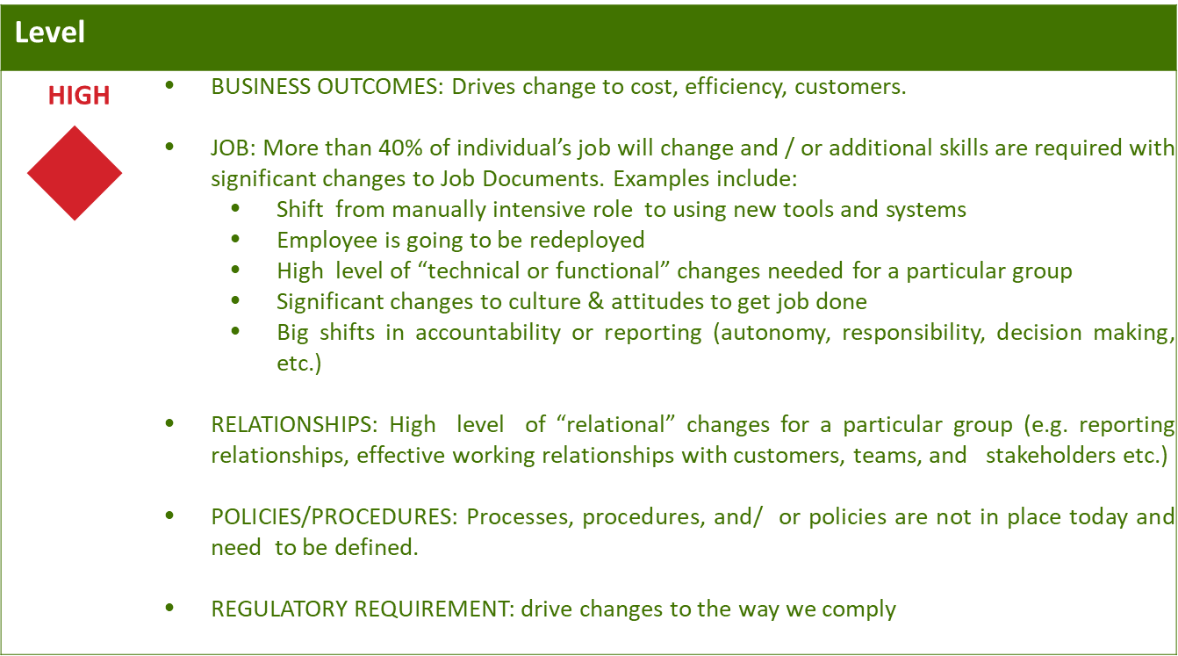
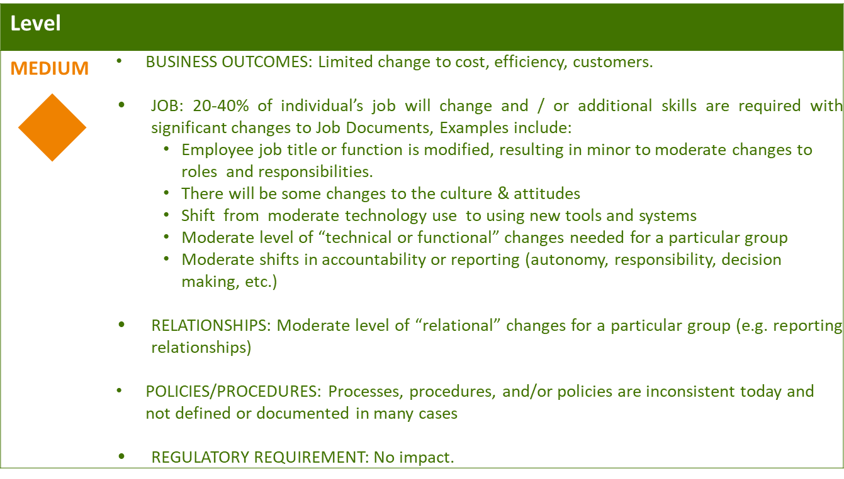
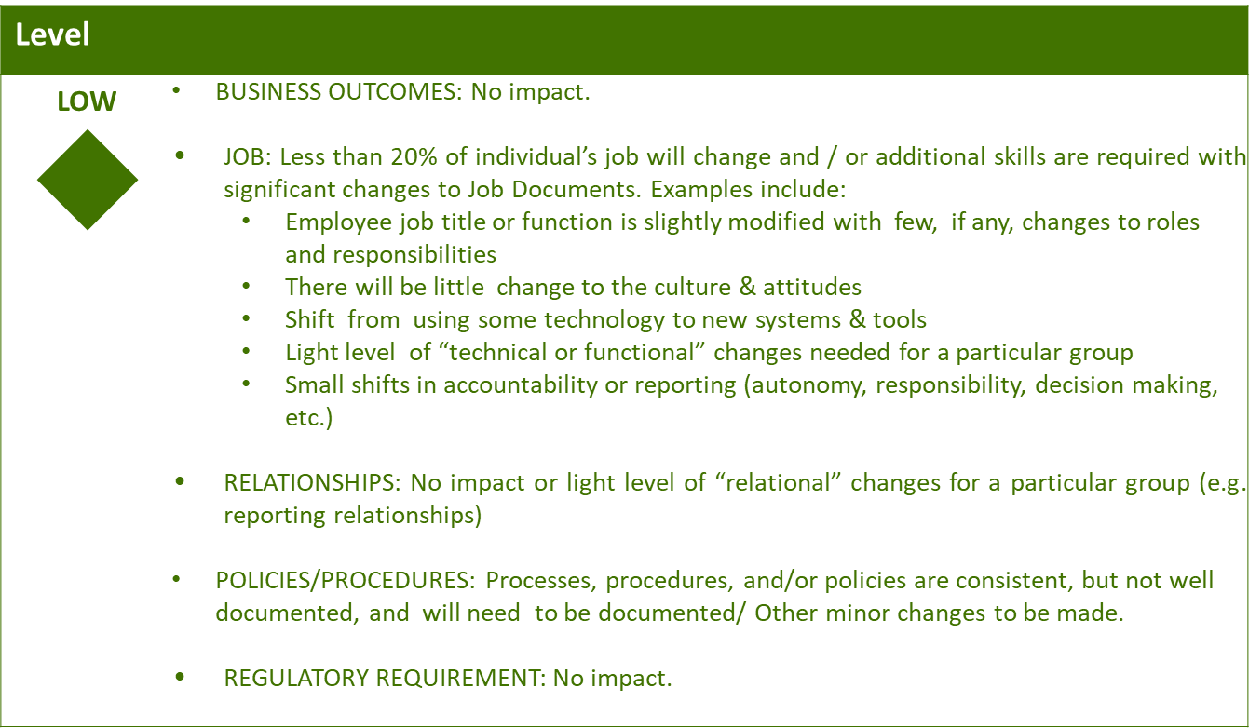

Business Effort: Initial assessment of the impact to the business High, Medium, Low

Requirements
Requirement # | APSE Requirement # | Requirement Description

7. Appendix

